# IE4717 Web Application Design - Project Report

**Design project group number:** F38-DG15

**Team members:** Ng Sheng Feng, Chen Qi

**Project Title:** Easymoviesbooking.com

**Summary of Project:**

This project aims to create a website that would guide users through the online process of booking a physical movie, from selecting movie’s showtime and cinema, to choosing seating plan.

It would allow users to pick desired movies from a selection of movies, select seating plan, pick time slots, choose the type of tickets available (standard, premium etc.) along with their prices, and checkout. Upon successful checkout, users can check their booking details.

As such, customers will be able to complete the process of booking movies through an online website, saving the hassle of the need to go to the physical counter of a cinema to book a movie.

IE4717 Web Application Design - Project Report 1

1. Application requirements and specifications 3

2. Function requirements and specifications 3

3. Design of the web application 4

3.1 Site Map 4

3.2 Storyboard 5

3.3 Wireframe 8

### 

## 1. Application requirements and specifications

This website guides customers through the process of selecting a movie, picking a time slot, choosing seating plan, opting for ticket(s)’s type and price, and thereafter making payment. After the booking process, customers would be able to view their booking details and display it to the cinema’s staff before entry.

1. Allows users to log in into the website, and to register for an account if they have not yet created an account previously.
2. If the users already know what they want to watch, they can choose their desired movie, cinema, and showtime with the “Quick Buy” search box, which is located on the home page.
3. Otherwise, users can browse through a selection of movies currently showing in the cinema on the homepage.
4. Users would be able to view movies’ descriptions and details, along with cinemas’ locations and movies’ showtimes.
5. Users can choose their desired seating plan out of the available seatings that are yet to be booked by other customers.
6. Users can select the ticket type(s) (tagged along with the corresponding prices), and make payment for the movie booking.
7. Users would be able to check their booking details.

## 2. Function requirements and specifications

1. At the homepage, users can choose to “Sign in/ Register” on the navigation bar. Upon clicking on the hyperlink, a small box would pop out of the current page prompting users to key in their username and password to sign in to their account. If they have not signed up yet, they can then click on the “Register” hyperlink in the small box which would bring them to a Sign-Up page.
2. To allow users to book a movie that they already have in mind in a quick-and-easy process, a search box will be displayed at the top of the homepage, with which they can select the movie, cinema and timeslot.
3. The home page would display movie banners that are showing in the cinemas, if the users are interested to find out more details about the movies, they can click into the respective movie banner.
4. The new page would show the movie’s description, cinema’s locations and movie’s showtimes.
5. After selecting the desired movie to watch, cinema’s locations and movie’s showtime in the previous step, a seating plan would be displayed accordingly and users can select from the available seating plan. Seatings that have already been booked by other users would be blocked off for selection.
6. Finally, users would see a summary of the booking details, be required to select the type(s) of ticket(s) from a dropdown list, and make payment online.
7. Users would be able to navigate through the navigation bar on the homepage to view booking details, with which they are required to input their mobile number and email and the web page would show their booking detail(s).

## 3. Design of the web application

### 3.1 Site Map

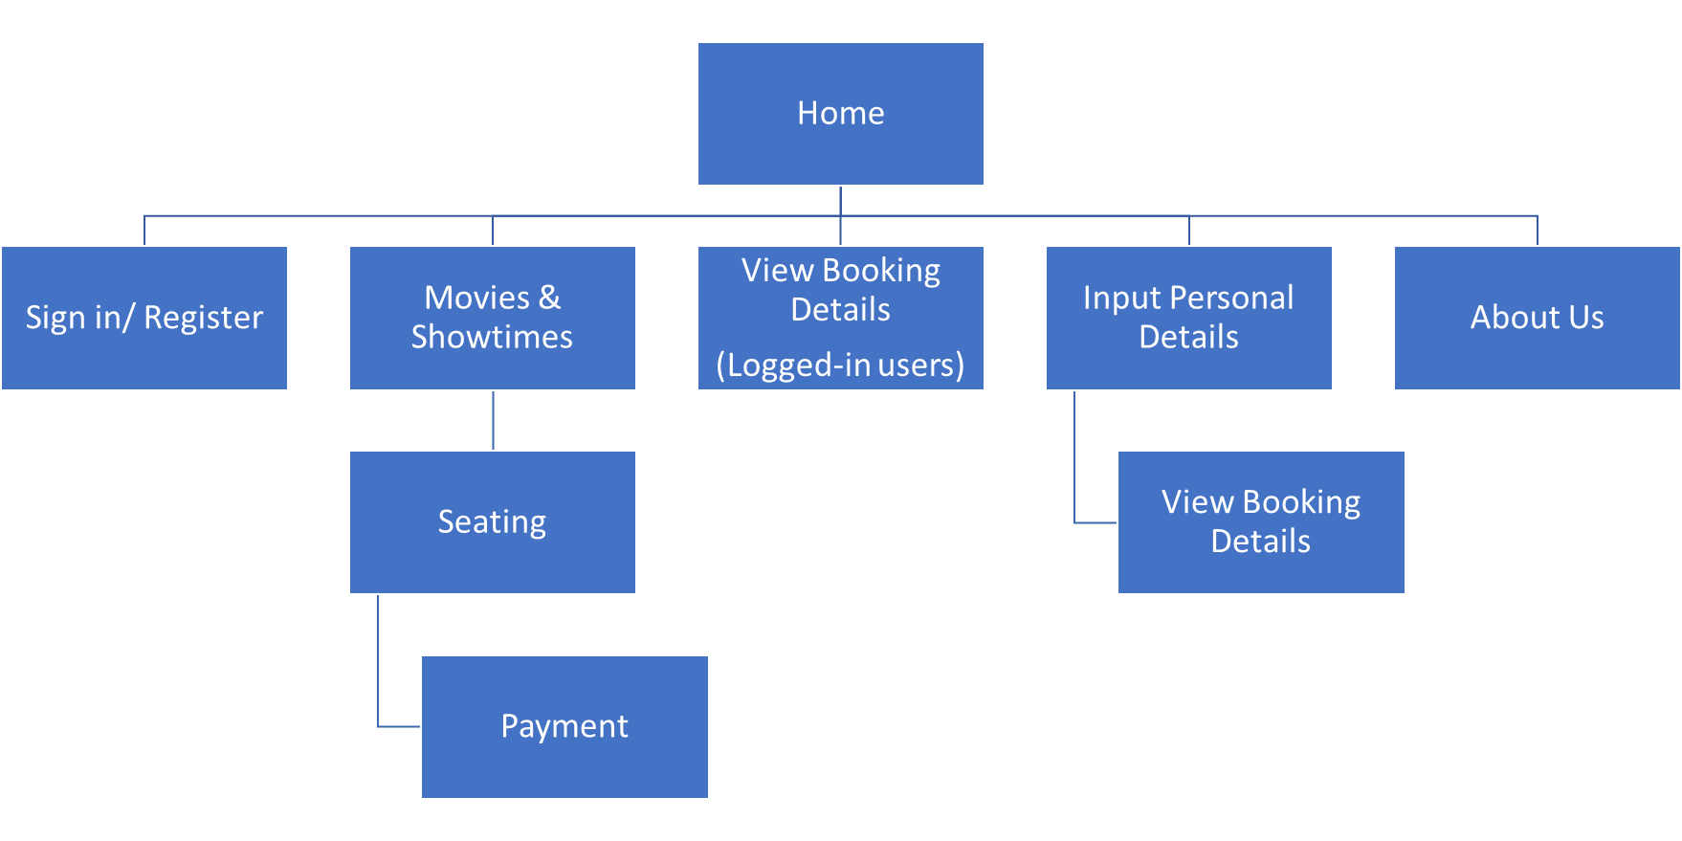

Figure 1. Sitemap of Booking Website

### 3.2 Storyboard

Registration:

Log in:

Performing movie booking process:

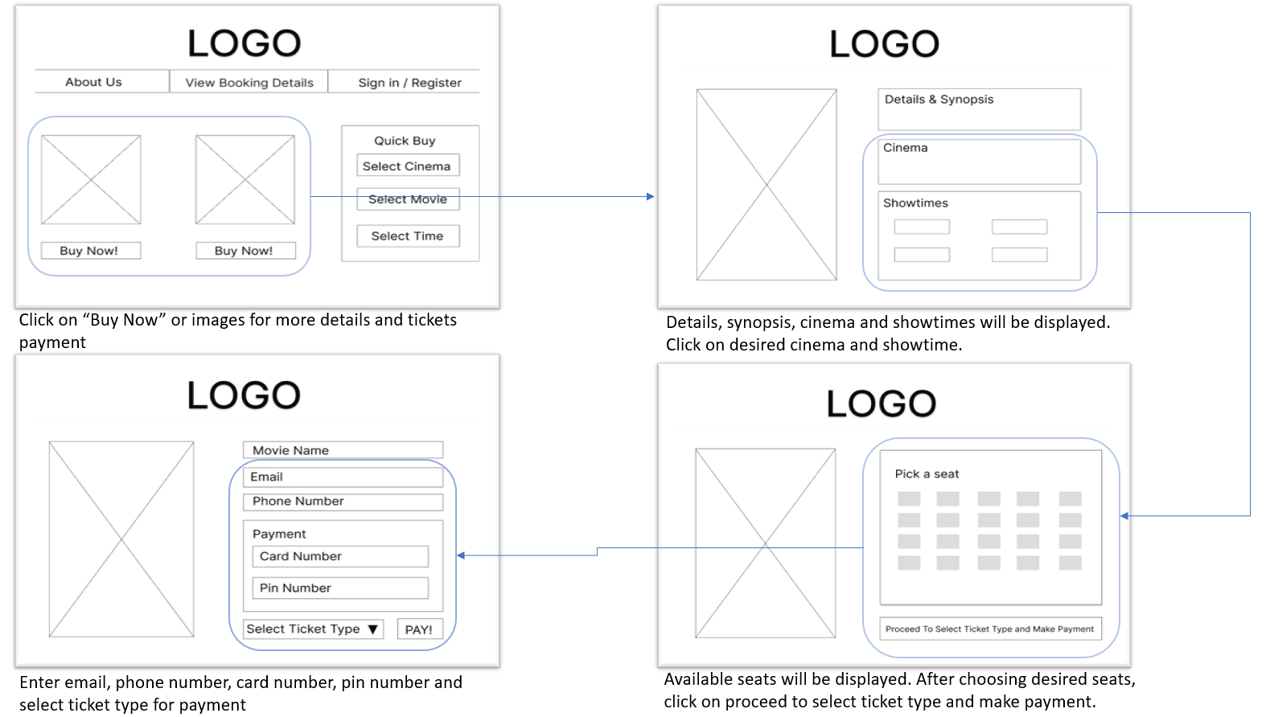

Check Details (without log-in):

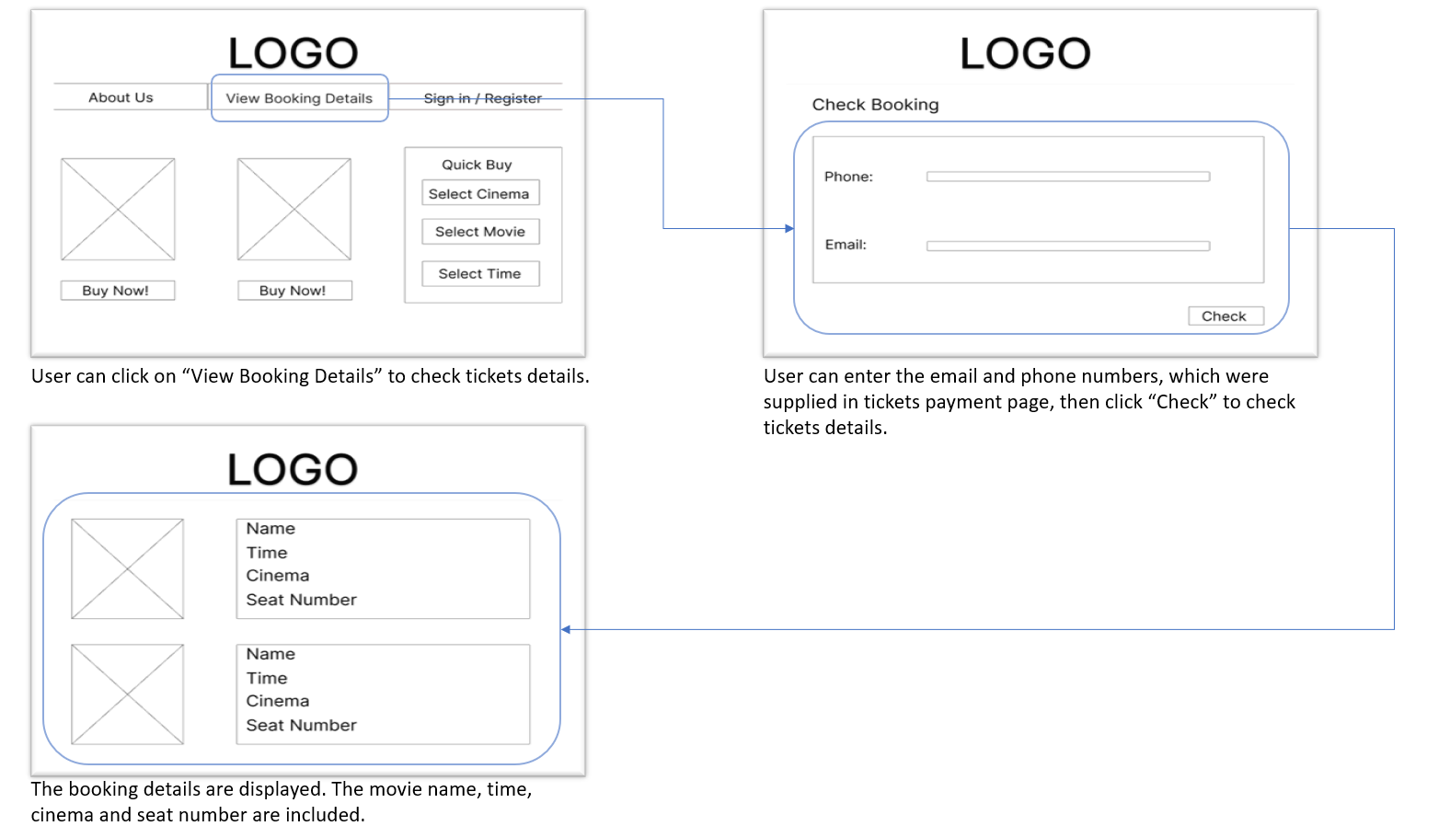

Check Details (user has logged-in):

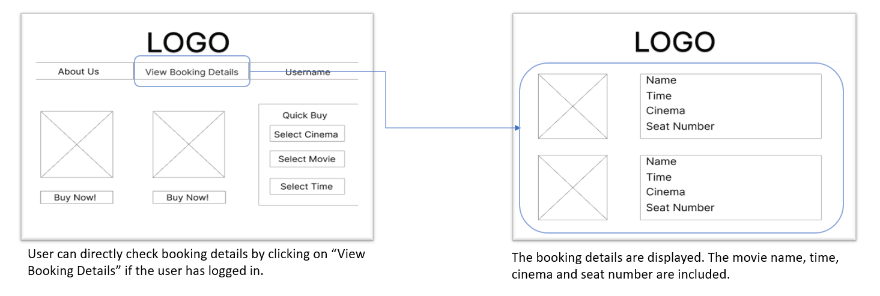

About us: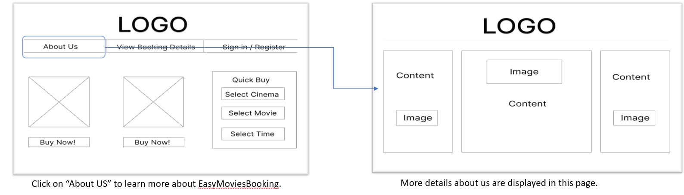

### 3.3 Wireframe

Home Page:

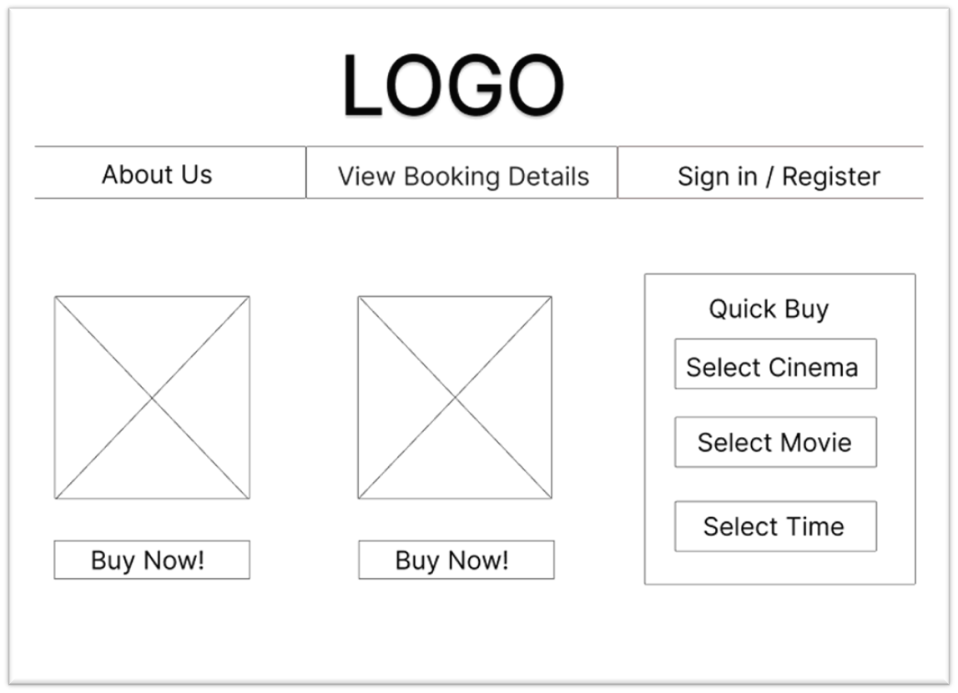

About Us:

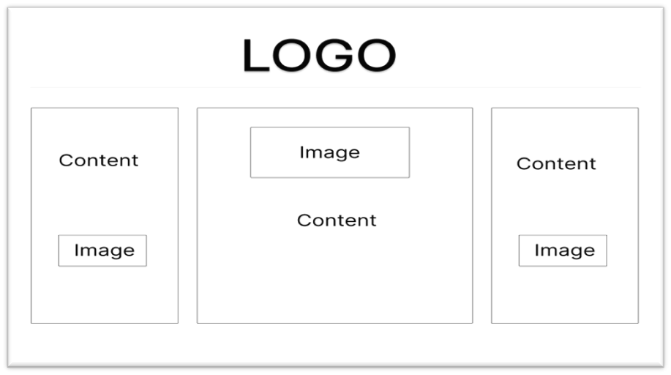

Check Booking With Phone and Email:

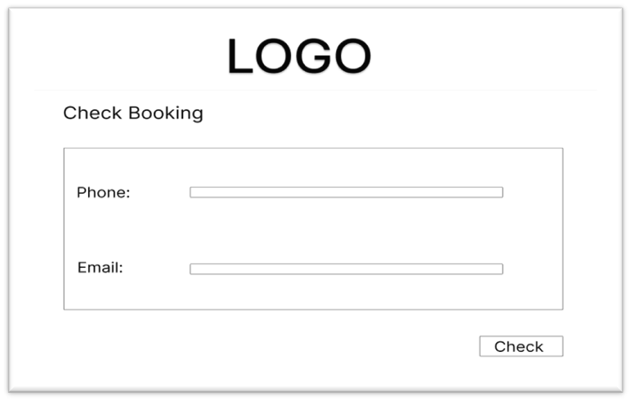

View Booking Details:

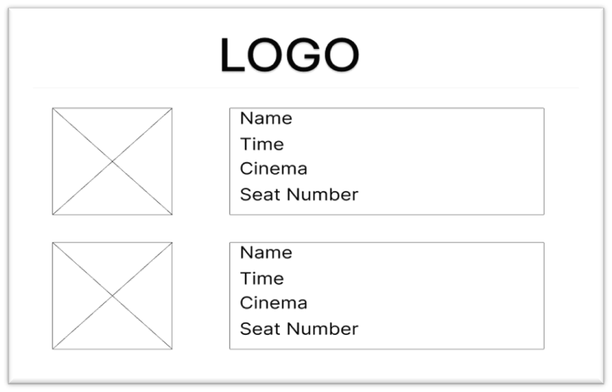

Registration:

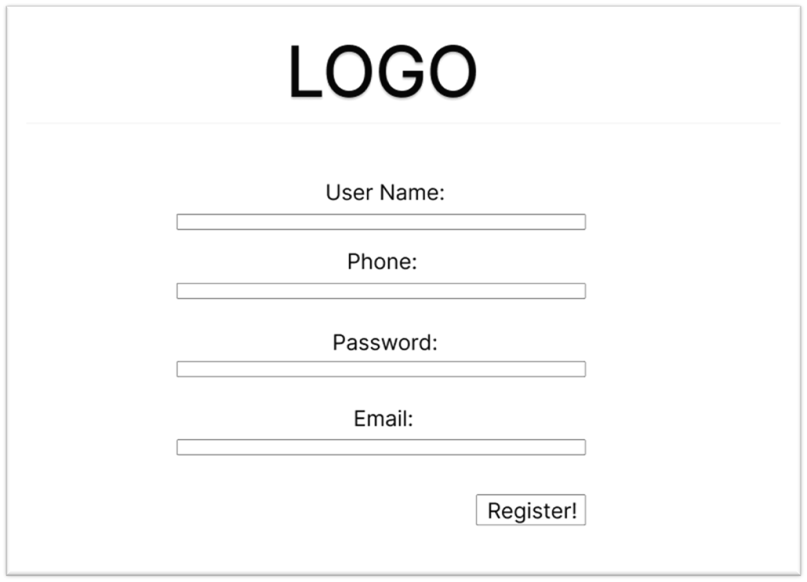

Movies & Showtimes:

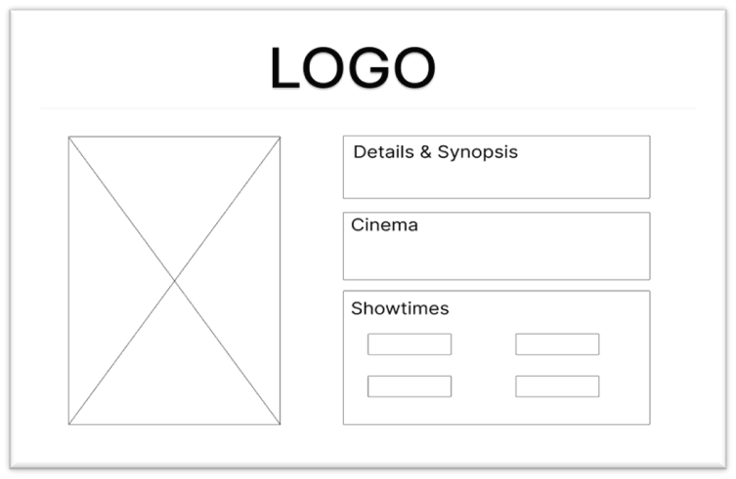

Seating:

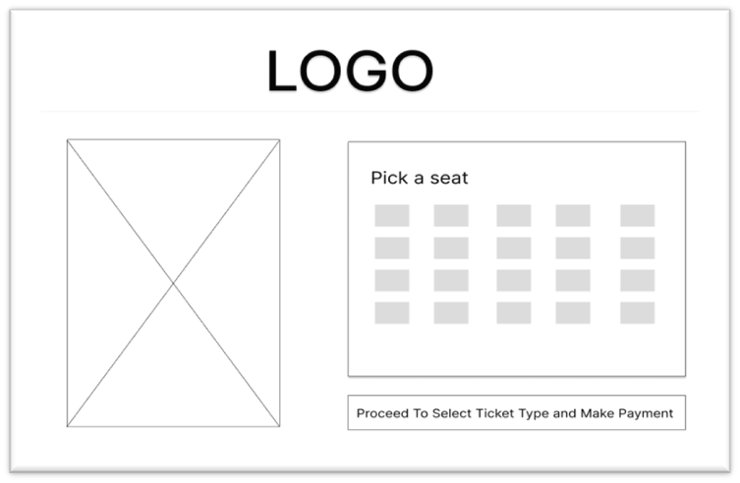

Payment:

